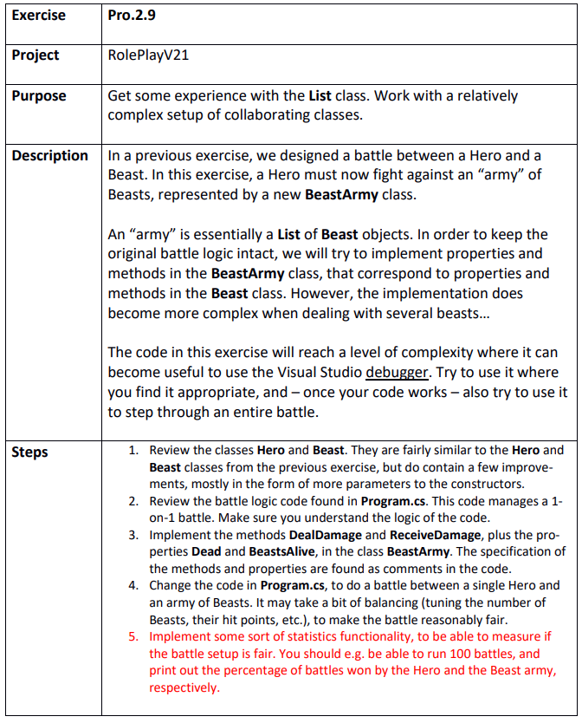

Step 1
RolePlayV21.sln
The constuctors have gotten maxhp, min and max dmg as extra inputs and maxhp is a separate instance field now

Step 2
The battle logic continues while both are alive. Hero has first move and when it’s the beasts turn it first checks whether it is alive to do it’s move

Step 3
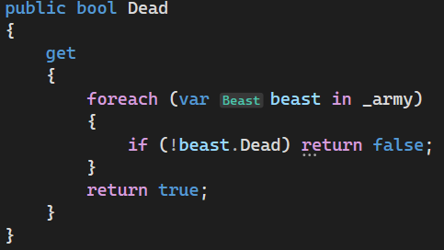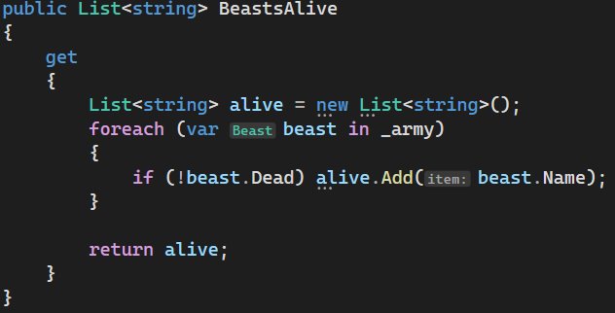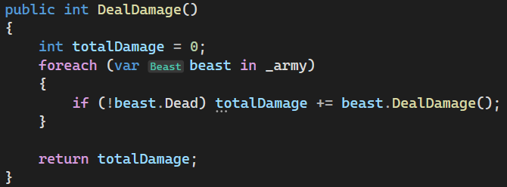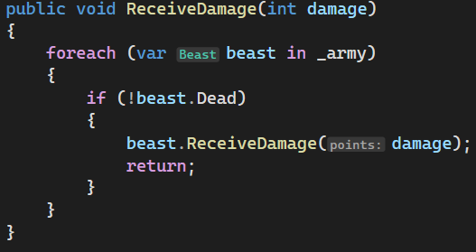

Step 4
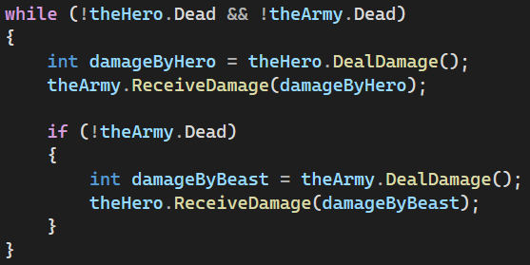

Step 5
